**Lab Objectives**

* Data Validation with direct and indirect list
* Conditional formatting
* Sorting and filter
* Define range names

**Data Validation with direct and indirect list**

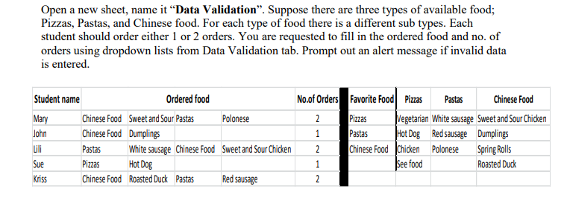

**Conditional formatting**

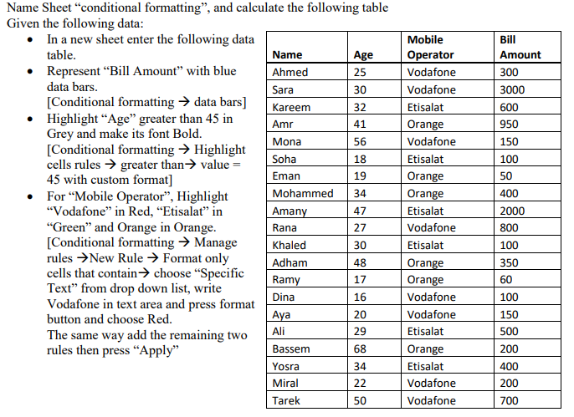

**Sorting and filter**   
  
From the last exercise data get all Vodafone mobile operators with more than 24 age   
  
**Define range names**  
From the last exercise data define the Bill amount range and name it “Bill_Amount” then get the sum and average of the Bill Amounts using the definition.